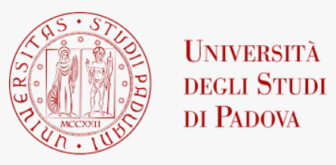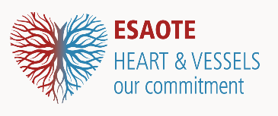
WORKSHOP ON INTRACARDIAC FLOW DYNAMICS
The Role of the HyperDoppler Technique
PADUA UNIVERSITY
Department of Cardiac Thoracic Vascular Sciences and Public Health
June 23-24, 2022

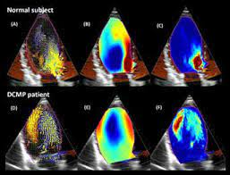
This workshop focuses on current role and perspectives of the ultrasound evaluation of intracardiac flow dynamics. Technical aspects and clinical applications of current ultrasound technology, including HyperDoppler, will be discussed by an international working group. Area of future developments and cooperative projects will be identified. The workshop will be conducted with a hybrid format, including on-site and on-line participation.

DAY 1 – June 23rd

13:30-14:00 Registration

14:00-14:15 Introduction

14:15-16:00 Session I
14:15-15:00 Fluid dynamics in cardiology
15:00-15:30 Overview on clinical applications of vortex analysis
15:30-16:00 General discussion

16:00-17:00 Coffee break with practical sessions with HyperDoppler

17:00-18:30 Session II
17:00-17:30 Our experience with HyperDoppler
17:30-18:00 Vortex analysis: past, present and future
18:00-18:30 General discussion

20:00 Social Dinner

DAY 2 – June 24th

09:00-09:30 Lecture - Non-ultrasound techniques for intracardiac flow dynamics: 4D flow

09:30-11:00 Round table - The future of ultrasound evaluation of intracardiac flow dynamics

Topics: technical developments, potential clinical applications, areas of clinical and experimental research, proposals for cooperative projects.

11:00-11:30 Coffee break

11:30-12:30 Clinical cases and examples of vortex flow analysis

12:30-12:45 Conclusions

12:45-13:30 Light lunch

